Input docs test

This process consists in two tasks where first task is assigned a dynaform and two input documents, one with versioning and the o

ther one without versioning. The administrator is to execute the process.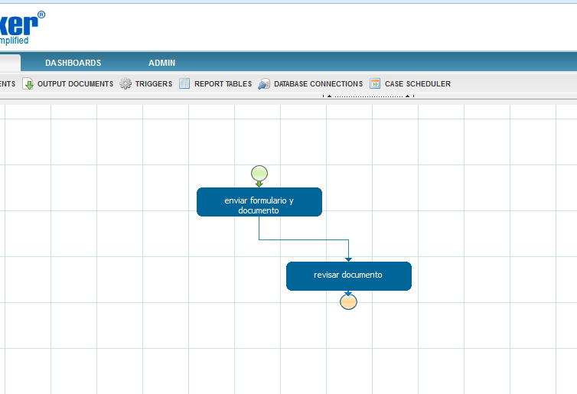

Process’ design

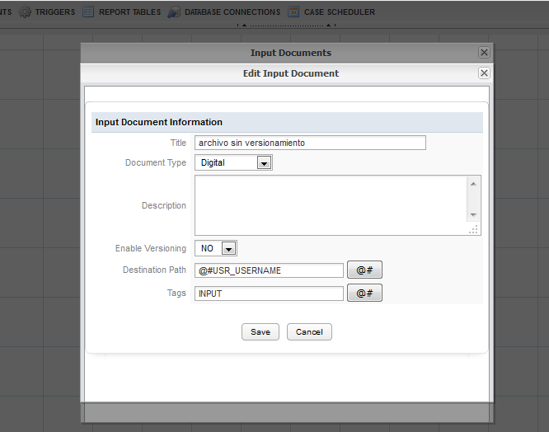

Window which creates an input document without versioning

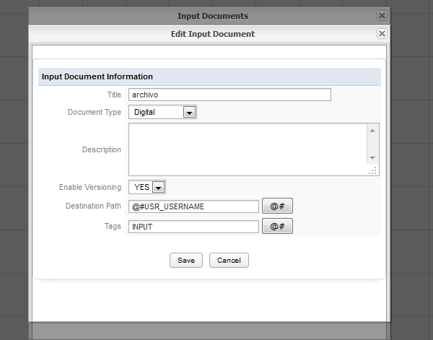

This option creates an input document with versioning

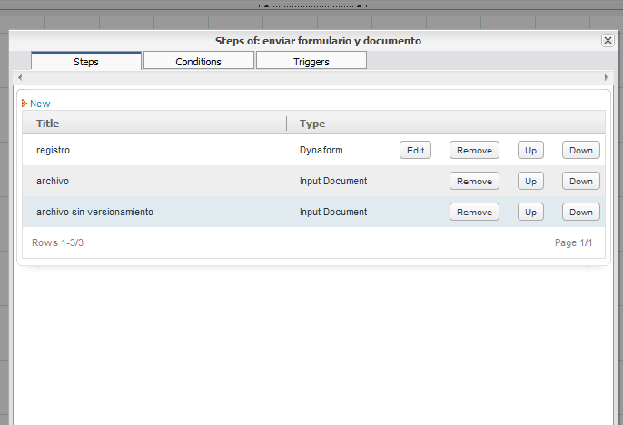

The step option assings docs and dynaforms to an specific user, in this case the administrator was assigned.